**VISVESVARAYA TECHNOLOGICAL UNIVERSITY BELAGAVI – 590 018**



**MINI PROJECT REPORT ON**

**“Student Database manager”**

Submitted In Partial Fulfillment of 6th semester WTA laboratory with Mini Project (18CS63)

**Bachelor of Engineering**

In

**Computer Science & Engineering**

**Submitted By:**

**Manjappa (3GN20CS037)**

Under the guidance of

**Mr. SANDEEP IDDALGAVE**

**Asst. Professor**



**GURU NANAK DEV ENGINEERING COLLEGE**

**BIDAR-585401**

**Department of Computer Science & Engineering**

**Accredited by NBA, New Delhi**

**GURU NANAK DEV ENGINEERING COLLEGE**

**BIDAR-585401, KARNATAKA**

Approved by AICTE, New Delhi & Affiliated to VTU, Belagavi

Phone: 08482- 226949

Website:www.gndecb.ac.in



**DEPARTMENT OF COMPUTER SCIENCE AND ENGINEERING**

**CERTIFICATE**

This is to certify that the Mini Project Report entitled “**Student Database Manager**” is a bonafide work carried out by **Manjappa(3GN20CS037)**in partial fulfillment of the WTA Laboratory with Mini Project(18CS63) for 6th semester Bachelor of Engineering in Computer Science & Engineering during the year 2022-23. It is certified that all the corrections/suggestions indicated for Internal Assessment have been incorporated in the report deposited in the department library. The mini project has been approved as it satisfies the academic requirements in respect of laboratory work prescribed for the said degree.

**Signature of Guide**

**Prof. Sandeep Iddalgave**

**STUDENT Database Manager**

**1. HTML CODE**

<!doctype html>

<html lang="en">

<head>

    <meta charset="utf-8">

    <meta name="viewport" content="width=device-width, initial-scale=1">

    <title>Collage Addmission</title>

    <link rel="stylesheet" href="style.css">

</head>

<body>

    <div class="container">

        <div class="formcontainer">

            <form action="" id="formid">

                <div class="row">

                    <div class="col-25">

                        <label for="name">Full Name</label>

                    </div>

                    <div class="col-75">

                        <input type="text" id="name" name="name" placeholder="Your name..">

                    </div>

                </div>

                <div class="row">

                    <div class="col-25">

                        <label for="fname">Father Name</label>

                    </div>

                    <div class="col-75">

                        <input type="text" id="fname" name="Fathername" placeholder="Your Father name..">

                    </div>

                </div>

                <div class="row">

                    <div class="col-25">

                        <label for="birthday">Date of Birth</label>

                    </div>

                    <div class="col-75">

                        <input type="date" id="birthday" name="birthday">

                    </div>

                </div>

                <div class="row">

                    <div class="col-25">

                        <label for="cname">PUC College Name</label>

                    </div>

                    <div class="col-75">

                        <input type="text" id="cname" name="Collegename" placeholder="Your College name..">

                    </div>

                </div>

                <div class="row">

                    <div class="col-25">

                        <label for="pucPerct">PUC Percentage</label>

                    </div>

                    <div class="col-75">

                        <input type="number" id="pucPerct" name="pucPerct" placeholder="Your PUC Percentage">

                    </div>

                </div>

                <div class="row">

                    <div class="col-25">

                        <label for="">Address</label>

                    </div>

                    <div class="col-75">

                        <textarea name="" id="address" cols="10" rows="1"></textarea>

                    </div>

                </div>

                <div class="row">

                    <div class="col-25">

                        <label for="">Select Branch</label>

                    </div>

                    <div class="col-75">

                        <input type="radio" id="cse" name="branch" value="Computer Science">

                        <label id="branch" for="cse">Computer Science</label><br>

                        <input type="radio" id="ece" name="branch" value="Electronic Communication">

                        <label id="branch" for="ece">Electronic Engineering</label><br>

                        <input type="radio" id="eee" name="branch" value="Electrical">

                        <label id="branch" for="eee">Electric Engineering</label>

                    </div>

                </div>

                <br>

                <div class="row">

                    <input type="submit" value="Submit" id="submit">

                </div>

            </form>

        </div>

    </div>

    <div class="container ">

        <div style="overflow-x:auto;" id="tcont"></div>

    </div>

*<!-- <button id="1" class="btn-d" onclick="deleteStu(this.id)">Delete</button> -->*

    <script src="index.js"></script>

</body>

</html>

**CSS CODE**

* {

    box-sizing: border-box;

}

.container {

    width: 80%;

    margin: auto;

}

input[type=text],

input[type=number],

select,

textarea {

    width: 100%;

    padding: 12px;

    border: 1px solid #ccc;

    border-radius: 4px;

    resize: vertical;

}

input[type=date] {

    width: 100%;

    padding: 12px;

    border: 1px solid #ccc;

    border-radius: 4px;

}

label {

    padding: 12px 12px 12px 0;

    display: inline-block;

}

input[type=submit] {

    background-color: #04AA6D;

    color: white;

    padding: 12px 20px;

    border: none;

    border-radius: 4px;

    cursor: pointer;

    float: right;

}

input[type=submit]:hover {

    background-color: #45a049;

}

.formcontainer {

    border-radius: 5px;

    background-color: #f2f2f2;

    padding: 20px;

}

.col-25 {

    float: left;

    width: 25%;

    margin-top: 6px;

}

.col-75 {

    float: left;

    width: 75%;

    margin-top: 6px;

}

*/* Clear floats after the columns */*

.row:after {

    content: "";

    display: table;

    clear: both;

}

table {

    font-family: arial, sans-serif;

    border-collapse: collapse;

    width: 100%;

}

td,

th {

    border: 1px solid #dddddd;

    text-align: left;

    padding: 8px;

}

tr:nth-child(even) {

    background-color: #dddddd;

}

table {

    border-collapse: collapse;

    border-spacing: 0;

    width: 100%;

    border: 1px solid #ddd;

}

th,

td {

    text-align: left;

    padding: 8px;

    font-size: small;

}

tr:nth-child(even) {

    background-color: #f2f2f2

}

#tcont {

    margin: 10px 0px;

}

.btn-d{

    background-color: #04AA6D;

    color: white;

    border: none;

    padding: 6px;

    border-radius: 4px;

    cursor: pointer;

}

*/* Responsive layout - when the screen is less than 600px wide, make the two columns stack on top of each other instead of next to each other */*

@media screen and (max-width: 600px) {

    .col-25,

    .col-75,

    input[type=submit] {

        width: 100%;

        margin-top: 0;

    }

    #branch {

        font-size: small;

    }

}

**JAVASCRIPT**

**class studentDetails {**

**constructor(*sName*, *fName*, *dob*, *cName*, *per*, *address*, *branch*) {**

**this.sName = sName;**

**this.fName = fName;**

**this.dob = dob;**

**this.cName = cName;**

**this.per = per;**

**this.address = address;**

**this.branch = branch;**

**}**

**}**

**showDetails();**

**function deleteStu(*index*) {**

**if (confirm('Do you Want to Delete')) {**

**let stuDetails = localStorage.getItem("stuDetails");**

**if (stuDetails == null) {**

**stuArr = [];**

**}**

**else {**

**stuArr = JSON.parse(stuDetails);**

**}**

**stuArr.splice(index, 1);**

**localStorage.setItem('stuDetails', JSON.stringify(stuArr));**

**console.log(stuArr);**

**console.log(localStorage);**

**showDetails();**

**console.log(index);**

**}**

**}**

**function addLocalStorage(*stu*) {**

**let stuDetails = localStorage.getItem('stuDetails');**

**if (stuDetails == null) {**

**stuArr = [];**

**}**

**else {**

**stuArr = JSON.parse(stuDetails);**

**}**

**stuArr.push(stu);**

**localStorage.setItem('stuDetails', JSON.stringify(stuArr));**

**}**

**function formClear() {**

**let addmForm = document.getElementById('formid');**

**addmForm.reset();**

**}**

**function validate(*stu*) {**

**if (stu.sName < 2 || stu.fName < 2 || stu.dob < 2 || stu.cName < 2 || stu.address < 2 || stu.branch < 2) {**

**return false;**

**}**

**else {**

**return true;**

**}**

**}**

**function showDetails() {**

**let stuDetails = localStorage.getItem('stuDetails');**

**if (stuDetails == null) {**

**stuObj = [];**

**}**

**else {**

**stuObj = JSON.parse(stuDetails);**

**}**

**document.getElementById('tcont').innerHTML = `**

**<table id="table">**

**<tr>**

**<th>Index</th>**

**<th>Student Name</th>**

**<th>Father Name</th>**

**<th>Student Date of Birth</th>**

**<th>Puc College Name</th>**

**<th>Puc Percentage</th>**

**<th>Student Adress</th>**

**<th>Slected Branch</th>**

**<th>Delete</th>**

**</tr>**

**</table>**

**`;**

**stuObj.forEach((*element*, *index*) => {**

**let table = document.getElementById('table')**

**let trow = document.createElement('tr');**

**trow.innerHTML = `**

**<th>${index + 1}</th>**

**<th>${element.sName}</th>**

**<th>${element.fName}</th>**

**<th>${element.dob}</th>**

**<th>${element.cName}</th>**

**<th>${element.per}%</th>**

**<th>${element.address}</th>**

**<th>${element.branch}</th>**

**<th> <button id="${index}" class="btn-d" onclick="deleteStu(this.id)">Delete</button></th>**

**`;**

**table.appendChild(trow);**

**});**

**}**

**let addmForm = document.getElementById('formid');**

**addmForm.addEventListener('submit', addmFormSubmit);**

**function addmFormSubmit(*e*) {**

**let name = document.getElementById('name').value;**

**let fatherName = document.getElementById('fname').value;**

**let dob = document.getElementById('birthday').value;**

**let collegeName = document.getElementById('cname').value;**

**let percentage = document.getElementById('pucPerct').value;**

**let address = document.getElementById('address').value;**

**let cse = document.getElementById('cse');**

**let ece = document.getElementById('ece');**

**let eee = document.getElementById('eee');**

**let branch;**

**if (cse.checked) {**

**branch = cse.value;**

**}**

**else if (ece.checked) {**

**branch = ece.value;**

**}**

**else if (eee.checked) {**

**branch = eee.value;**

**}**

**let stu = new studentDetails(name, fatherName, dob, collegeName, percentage, address, branch);**

**if (validate(stu)) {**

**addLocalStorage(stu);**

**showDetails();**

**formClear();**

**}**

**else {**

**alert('Form is Empty');**

**}**

**e.preventDefault();**

**}**

**OUTPUT**

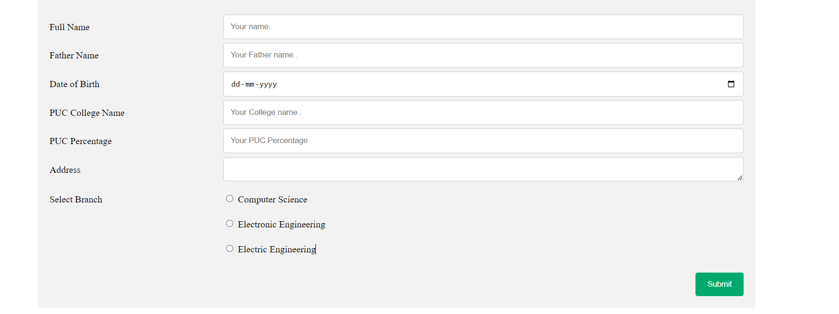

*Fig: Student FORM*

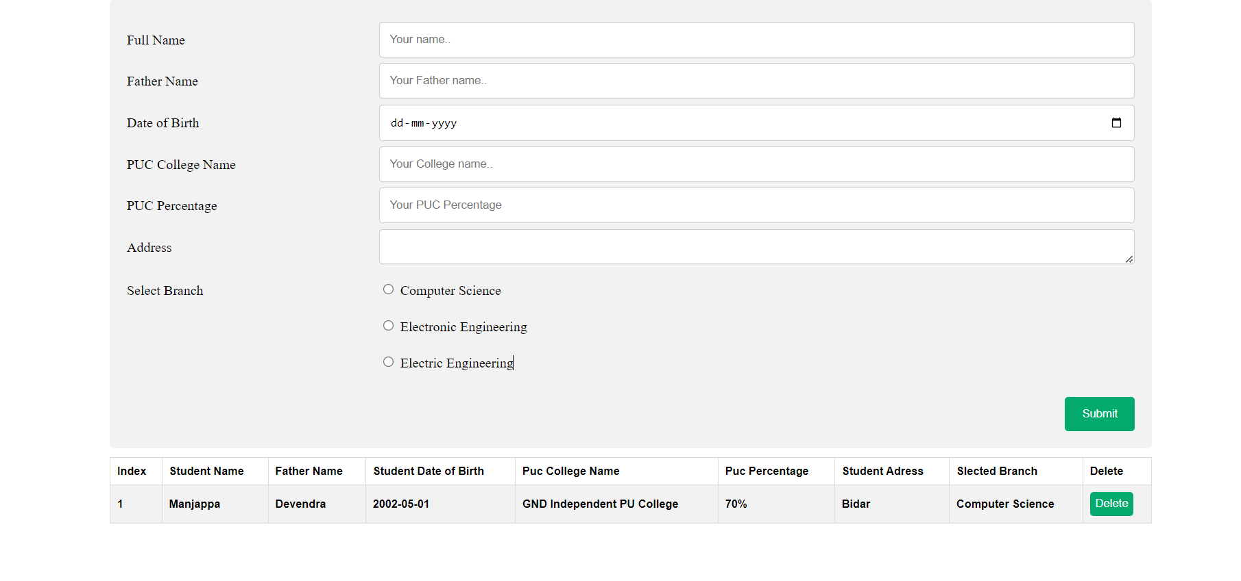

*Fig: Student Data*